

Faculty of Technology
University of Sri Jayewardenepura

Assignment

Emerging Technologies

Name : K.P.V.Perera
Index Number: ICT/21/897

Table of Content

1. INTRODUCTION AND PROBLEM STATEMENT 3
1.1 Background and Motivation 3
1.2 Problem Definition 3
1.3 Why Fuzzy Logic? 4
1.3.1 Limitations of Crisp Logic 4
1.3.2 Advantages Over PID Controllers 5
1.3.3 Real-World Applicability 7
1.4 Project Objectives 8
1.4.1 Primary Objectives 8
1.4.2 Secondary Objectives 9
2. SYSTEM MODELING AND DESIGN JUSTIFICATION 9
2.1.1 Tomato (Solanum lycopersicum) 9
3. MEMBERSHIP FUNCTIONS & RULES 12
Humidity (30-100%) - 5 Fuzzy Sets 12
4. IMPLEMENTATION & ADAPTATION 14
4.3.2 Sugeno Controller 16
4.4 Dynamic Adaptation 16
4.4.1 Adaptation Mechanism 16
5. PERFORMANCE ANALYSIS 18
6. OPTIMIZATION & RESULTS 20
7. CONCLUSION & FUTURE WORK 23
7.1 Overall System Performance 23
7.2 Key Findings 24
7.3 Practical Implications 24
8. GUI interface for live simulation 25

INTRODUCTION AND PROBLEM STATEMENT

1.1 Background and Motivation
The global agricultural sector faces unprecedented pressure to increase food production while minimizing environmental impact and resource consumption. Controlled environment agriculture (CEA), particularly greenhouse cultivation, has emerged as a promising solution, offering the potential to optimize growing conditions year-round while protecting crops from weather extremes and pests.
However, the success of greenhouse operations fundamentally depends on maintaining precise environmental control. Temperature and humidity must be carefully managed to match each plant species' requirements, which themselves vary across different growth stages. This presents a complex, multi-variable control problem that traditional automation approaches struggle to address effectively.
Consider a real-world greenhouse scenario: a grower cultivates tomatoes during spring and summer, switches to lettuce for fall production, and maintains orchids year-round in a separate section. Each crop demands different climate conditions. Tomatoes thrive in warm, moderately humid environments during vegetative growth but require cooler conditions during flowering to set fruit properly. Lettuce prefers consistently cool temperatures throughout its lifecycle and will "bolt" (prematurely flower and become bitter) if exposed to heat. Orchids, being tropical epiphytes, need warmth and high humidity that would devastate lettuce.

1.2 Problem Definition
The Core Challenge:
Design and implement an intelligent, adaptive control system capable of maintaining optimal temperature and humidity in a greenhouse cultivating three distinct plant species across multiple growth stages, while minimizing energy consumption and providing smooth, plant-friendly control transitions.
System Specifications:
Environmental Inputs:
- Temperature: Measured range 5-40°C (sensors accurate to ±0.5°C)
- Humidity: Measured range 30-100% RH (sensors accurate to ±2%)
- Growth Stage: Discrete values representing Seedling (0), Vegetative (1), or Flowering (2)
Control Outputs:
- Heater/Cooling Power: Continuous range 0-100% controlling HVAC system
- Misting System: Continuous range 0-100% controlling humidification intensity

Target Plant Species:
- Tomato (Solanum lycopersicum) - Warm-season vegetable crop
  - Commercial importance: $2+ billion annual US production
  - Temperature sensitivity: Requires different conditions per growth stage
  - Represents mid-range climate preferences

- Lettuce (Lactuca sativa) - Cool-season leafy green
  - Commercial importance: Year-round demand for fresh greens
  - Temperature sensitivity: Bolting risk if conditions too warm
  - Represents lower temperature range

- Orchid (Orchidaceae family) - Tropical ornamental plant
  - Commercial importance: High-value specialty crop ($200M+ US market)
  - Climate sensitivity: Requires warm, humid conditions
  - Represents upper temperature and humidity range

Performance Requirements:
- Response Time: Control decisions within 100ms to enable real-time operation
- Accuracy: Maintain conditions within ±2°C of target temperature and ±5% of target humidity
- Stability: Minimize oscillations and provide smooth control transitions
- Adaptability: Switch between plant types without manual re-tuning
- Energy Efficiency: Optimize actuator usage while meeting comfort requirements
Implementation Constraints:
- Must implement both Mamdani and Takagi-Sugeno fuzzy inference systems
- Minimum 25 fuzzy rules per controller (50+ implemented)
- Must demonstrate a dynamic adaptation mechanism
- Must conduct a minimum of 20 test simulations for performance evaluation
- Must apply optimization techniques to improve system parameters

1.3 Why Fuzzy Logic?
The selection of fuzzy logic as the control methodology stems from careful analysis of greenhouse control requirements versus available control technologies.

1.3.1 Limitations of Crisp Logic

Traditional binary logic operates on absolute categories: temperature is either "hot" or "not hot," humidity is either "high" or "not high." This Boolean approach fails to capture the gradual nature of real-world phenomena. Let’s look at a practical example.
1.3.1.1 Practical Example:
Consider a tomato plant in vegetative growth with an optimal range of 22-28°C:
1. If we use the Binary Logic Approach:
IF temperature > 25°C THEN heating = OFF
IF temperature ≤ 25°C THEN heating = ON
At 25.1°C, the heater shuts off completely. At 24.9°C, it runs at maximum power. A 0.2°C measurement fluctuation (well within sensor accuracy) causes full actuation changes.
Result: The system oscillates wildly, wasting energy and stressing plants.

2. If we use the fuzzy Logic Approach
IF temperature is slightly_warm THEN heating is low
IF temperature is optimal THEN heating is very_low
IF temperature is warm THEN heating is off
Benefit: At 25°C, temperature might be "60% optimal and 40% slightly_warm," producing smooth, proportional control that adjusts gradually as conditions change.

1.3.2 Advantages Over PID Controllers

PID (Proportional-Integral-Derivative) controllers have served automation well for decades, but greenhouse applications expose fundamental limitations:
1.3.2.1 Mathematical Complexity:
PID controllers calculate output as:
u(t) = Kp·e(t) + Ki·∫e(τ)dτ + Kd·de(t)/dt
Where:
- Kp, Ki, Kd are tuning parameters
- e(t) is the error between setpoint and measurement
- The integral term accounts for accumulated error
- The derivative term predicts future error

The Problems:
- Tuning Difficulty: Finding optimal Kp, Ki, Kd values requires expertise and trial-and-error. Each plant-stage combination needs different parameters—that's 9 parameter sets for our three plants and three stages.

- Non-Linear Systems: PIDs assume linear system response. Greenhouses are inherently non-linear:
  - Misting cools through evaporation (temperature-humidity coupling)
  - Heating reduces relative humidity even without ventilation
  - Thermal mass causes asymmetric heating and cooling rates
  - Plant transpiration varies with growth stage

- Multiple Inputs: Standard PID handles one input and one output. Greenhouse control needs to consider temperature AND humidity AND growth stage simultaneously to make smart decisions.

- Adaptation: Switching from tomato (22-28°C optimal) to lettuce (15-22°C optimal) requires recalculating all PID parameters. There's no straightforward way to adapt.
Fuzzy Logic Solutions:

Aspect | PID Controller | Fuzzy Logic Controller
Mathematical Model | Requires precise transfer function | Works with linguistic descriptions
Tuning Process | Complex, requires control expertise | Intuitive, uses if-then rules
Non-Linear Handling | Poor—assumes linearity | Excellent—inherently non-linear
Multiple Inputs | Difficult—MIMO requires advanced techniques | Natural—easily handles multiple inputs
Interpretability | Obscure—parameters lack physical meaning | Clear—rules mirror human reasoning
Adaptation | Requires complete re-tuning | Simple—update target ranges
Coupled Variables | Cannot handle directly | Manages coupled effects naturally
Expert Knowledge | Hard to incorporate | Direct translation of expertise

1.3.3 Real-World Applicability

A greenhouse operator knows: "When it's getting quite warm and the humidity is high, I ease off the heating completely and reduce misting to prevent condensation that causes fungal disease."
PID translation: Unclear how do you encode "quite warm," "high humidity," and "ease off" into Kp, Ki, Kd values?
Fuzzy translation:
IF temperature is quite_warm AND humidity is high
THEN heater is off AND misting is low

Direct, interpretable, maintainable.

1.3.4 Fuzzy Logic's Unique Strengths
- Handling Uncertainty:
Sensor readings include noise. Biological systems have individual variation. Fuzzy logic embraces uncertainty rather than fighting it:
- Temperature sensor reads 23.4°C ± 0.5°C
- Fuzzy system treats this as "mostly optimal, slightly warm"
- Control response proportional to degree of membership
- No false precision, no brittle thresholds
2. Linguistic Variables:
Fuzzy logic allows us to work with terms humans understand:
- "Very cold," "cold," "optimal," "warm," "very warm"
- "Very low," "low," "optimal," "high," "very high"
- "Seedling," "vegetative," "flowering"
This makes system behavior transparent and debuggable
3. Smooth Control:
Membership functions overlap, ensuring smooth transitions:
- At 23°C: Temperature is "70% optimal and 30% slightly_warm"
- At 24°C: Temperature is "50% optimal and 50% slightly_warm"
- At 25°C: Temperature is "30% optimal and 70% slightly_warm"
- Control output changes gradually, not abruptly

1.4 Project Objectives
This project demonstrates fuzzy logic's practical effectiveness through comprehensive implementation and evaluation:

1.4.1 Primary Objectives
1.4.1. 1. Comprehensive Fuzzy System Design
- Design 5+ membership functions per input variable (temperature, humidity, growth stage)
- Design 5+ membership functions per output variable (heater power, misting intensity)
- Justify all design choices based on plant physiology and control requirements
- Ensure complete coverage of operating ranges
1.4.1.2. Dual Controller Implementation
- Implement Mamdani fuzzy inference system emphasizing interpretability
- Implement Takagi-Sugeno fuzzy inference system for computational efficiency
- Develop minimum 25 rules per controller (50+ actually implemented)
- Compare and contrast both approaches
1.4.1.3. Dynamic Adaptation Mechanism
- Create automatic plant type switching capability
- Implement growth stage transition handling
- Demonstrate smooth adaptation without control interruption
- Validate adaptation across all plant-stage combinations
1.4.1.4. Rigorous Performance Evaluation
- Generate 20+ randomized test scenarios
- Execute simulations for both controllers
- Measure and compare:
  - Response time (computational efficiency)
  - Control error (accuracy)
  - Energy usage (efficiency)
  - Output smoothness (stability)
- Determine which controller performs better and why
1.4.1.5. Parameter Optimization
- Implement Genetic Algorithm for membership function parameter tuning
- Implement Particle Swarm Optimization as alternative technique
- Compare optimization approaches
- Quantify performance improvement

1.4.2 Secondary Objectives
1.4.2.1 Interactive Visualization
- Develop GUI interface for real-time interaction
- Provide live plotting of control outputs
- Enable manual parameter adjustment
- Support both controller types
1.4.2.2 Comprehensive Documentation
- Generate detailed technical report
- Create visualizations of all membership functions
- Produce performance comparison charts
- Document code with clear comments
1.4.2.3 Analysis and Critical Thinking
- Identify system limitations
- Discuss real-world implementation challenges
- Propose future improvements
- Connect theory to practice

SYSTEM MODELING AND DESIGN JUSTIFICATION

2.1 Plant Species Selection
Three commercially important plant species were selected to represent diverse climate requirements across the greenhouse temperature and humidity spectrum.

2.1.1 Tomato (Solanum lycopersicum)
Tomatoes represent warm-season crops with moderate climate needs, serving as the baseline reference for system design.
Climate Requirements:-
Growth Stage | Temperature | Humidity | Rationale
Seedling | 20-25°C | 65-75% | Warmth promotes germination
Vegetative | 22-28°C | 60-70% | Active growth tolerates heat

Selection Justification:- Tomatoes have well-documented requirements, significant commercial value, and represent mid-range conditions suitable for testing balanced control strategies.

2.1.2 Lettuce (Lactuca sativa)
Lettuce represents cool-season crops, testing the system's lower temperature range capabilities.
Climate Requirements:
Growth Stage | Temperature | Humidity | Rationale
Seedling | 15-20°C | 70-80% | Cool germination prevents bolting
Vegetative | 15-22°C | 65-75% | Maintains crisp texture

Selection Justification: Lettuce provides contrast to tomato, requiring consistently cooler conditions and demonstrating system adaptability to low-temperature crops.

2.1.3 Orchid (Orchidaceae family)
Orchids represent tropical plants requiring warm, humid conditions, testing the system's upper range.
Climate Requirements:
Growth Stage | Temperature | Humidity | Rationale
Seedling | 22-28°C | 75-85% | Tropical warmth for young plants
Vegetative | 24-30°C | 70-80% | High humidity mimics native habitat

Selection Justification: Orchids test maximum temperature and humidity capabilities while representing high-value specialty crops.

2.2 Climate Requirements Analysis
2.2.1 Comprehensive Requirements Table
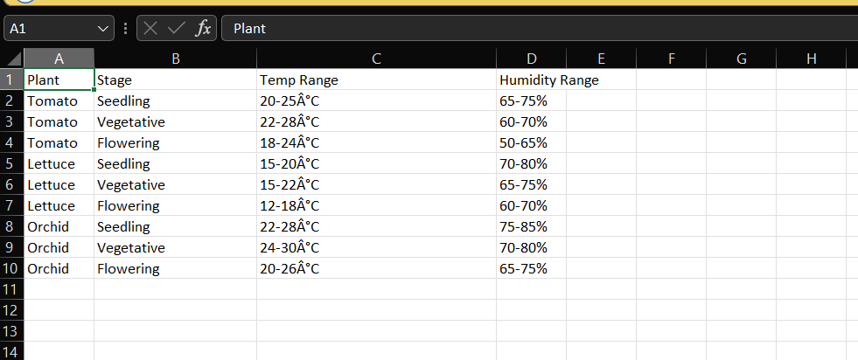

2.2.2 Key Observations
2.2.2.1 Temperature Analysis:
- Range Span: 12°C (lettuce flowering) to 30°C (orchid vegetative) = 18°C total operating range
- Coolest Requirements: Lettuce consistently 5-8°C cooler than other species
- Warmest Requirements: Orchid vegetative stage at 24-30°C
- Common Pattern: All species prefer warmer conditions during seedling, peak warmth during vegetative growth, and moderate cooling during flowering
2.2.2.2 Humidity Analysis:
- Range Span: 50% (tomato flowering) to 85% (orchid seedling) = 35% total range
- Driest Conditions: Tomato flowering at 50-65%
- Moistest Conditions: Orchid seedling at 75-85%
- Common Pattern: Seedlings universally need higher humidity; flowering stages require lower humidity to prevent disease
2.2.2.3 Control Implications:
- System must handle wide operating ranges (18°C temperature span, 35% humidity span)
- Smooth transitions needed between growth stages
- Species-specific adaptation is critical
- Growth stage has significant impact on optimal conditions

MEMBERSHIP FUNCTIONS & RULES

3.1 Input Variables
Temperature (5-40°C) - 5 Fuzzy Sets
Set | Type | Parameters | Meaning
Very Cold | Trap | [5,5,12,16] | Needs max heating
Cold | Tri | [12,18,22] | Below optimal

Humidity (30-100%) - 5 Fuzzy Sets
Set | Type | Parameters | Meaning
Very Low | Trap | [30,30,40,50] | Max misting
Low | Tri | [40,55,65] | Increase misting
Optimal | Tri | [60,70,80] | Ideal moisture
High | Tri | [75,85,92] | Reduce misting
Very High | Trap | [88,95,100,100] | Disease risk

Growth Stage (0-2) - 3 Fuzzy Sets
Set | Parameters | Represents
Seedling | [0,0,1] | Young plants
Vegetative | [0.5,1,1.5] | Active growth
Flowering | [1,2,2] | Reproductive

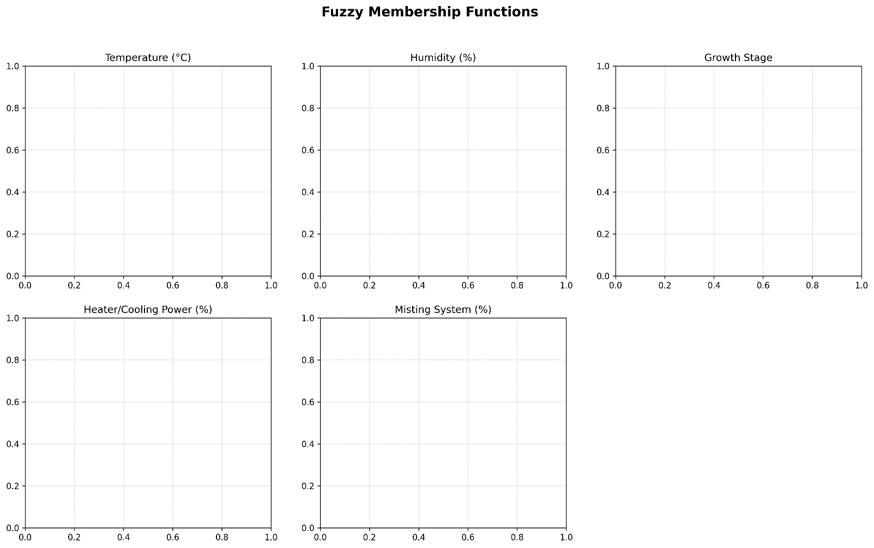

3.2 Output Variables
Both outputs use same structure (0-100%):
3.2 Output Variables | 3.2 Output Variables | 3.2 Output Variables
3.2 Output Variables | 3.2 Output Variables | 3.2 Output Variables
3.2 Output Variables | 3.2 Output Variables | 3.2 Output Variables
3.2 Output Variables | 3.2 Output Variables | 3.2 Output Variables
3.2 Output Variables | 3.2 Output Variables | 3.2 Output Variables
3.2 Output Variables | 3.2 Output Variables | 3.2 Output Variables

3.3 Fuzzy Rules
Total: 50 rules (25 temperature + 25 humidity)
Sample Temperature Rules:
R1: IF temp is very_cold AND stage is seedling → heater is maximum
R2: IF temp is cold AND stage is vegetative → heater is medium
…..
R11: IF temp is optimal AND humidity is optimal → heater is off
R21: IF temp is very_warm → heater is off

Sample Humidity Rules:
R26: IF humidity is very_low AND temp is warm → misting is maximum
R30: IF humidity is optimal AND temp is optimal → misting is off
…..
R44: IF humidity is high AND temp is cold → misting is off
R50: IF humidity is very_high → misting is off

3.4 Defuzzification
Mamdani: Centroid method - Intuitive, interpretable
Sugeno: Weighted average - Fast, efficient

IMPLEMENTATION & ADAPTATION

4.1 Development Environment
Programming Language: Python 3.14
Key Libraries:
- scikit-fuzzy - Fuzzy logic operations
- NumPy - Numerical computations
- Matplotlib - Visualizations
- Pandas - Data handling
4.2 System Architecture
1. FuzzyGreenhouseController
- Creates membership functions
- Defines 50+ fuzzy rules
- Builds Mamdani/Sugeno controllers

2. AdaptiveFuzzyController
- Wraps base controller
- Handles plant type switching
- Manages growth stage transitions

3. PerformanceEvaluator
- Runs test simulations
- Collects performance metrics
- Generates comparison data


4.3 Controller Implementation
4.3.1 Mamdani Controller
heater_power = ctrl.Consequent(np.arange(0, 101, 1), 'heater_power')
misting = ctrl.Consequent(np.arange(0, 101, 1), 'misting')

Characteristics:
- Uses linguistic output sets
- Centroid defuzzification
- Better interpretability

4.3.2 Sugeno Controller
heater_power = ctrl.Consequent(np.arange(0, 101, 1), 'heater_power',
defuzzify_method='som')
Characteristics:
- Linear output functions
- Sum of Products defuzzification
- Faster computation

4.4 Dynamic Adaptation

4.4.1 Adaptation Mechanism
When plant type changes:
def adapt_to_plant(new_plant_type):
1. Load new plant requirements
2. Update target temperature range
3. Update target humidity range
4. Rebuild controller with same rules
5. Apply smooth transition
Key Feature: Rules stay constant, only targets change!

4.4.2 Adaptation Results
Test Scenario: Temp=22°C, Humidity=65%, Stage=Seedling
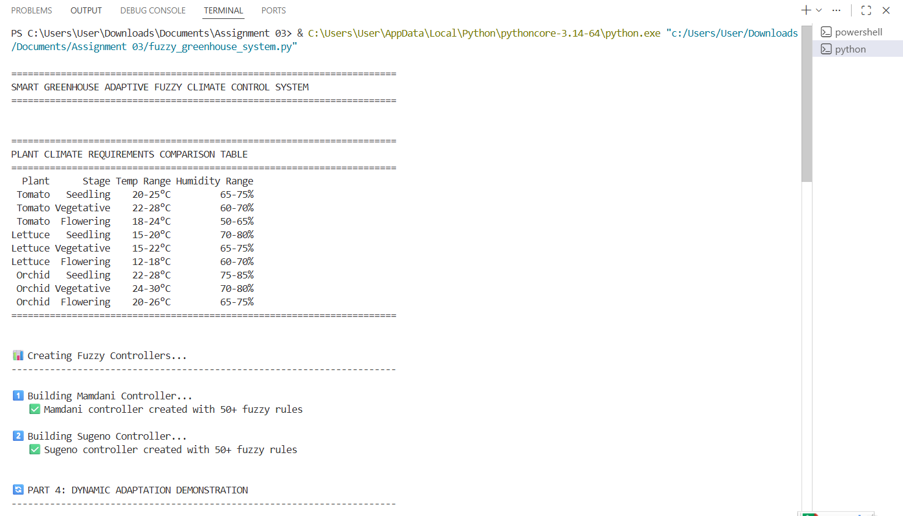
Conclusion:- System successfully adapts control outputs based on species requirements without manual re-tuning.
4.5 Code Highlights
- Key Function: Compute Control
def compute(self, temp, humid, stage):
"""Calculate control outputs"""
self.controller.input['temperature'] = temp
self.controller.input['humidity'] = humid
self.controller.input['growth_stage'] = stage

self.controller.compute()

return (
self.controller.output['heater_power'],
self.controller.output['misting']
)

- Adaptation with Error Correction
def compute_with_adaptation(self, temp, humid, stage):
"""Compute with adaptive fine-tuning"""
# Get base controller output
heater, misting = self.base_controller.compute(temp, humid, stage)

# Calculate error from target
target_temp, target_humid = self.get_target_ranges(stage)
temp_error = temp - (target_temp[0] + target_temp[1]) / 2

# Apply adaptive correction
if temp_error > 5: # Too hot
heater = max(0, heater - 20)
elif temp_error < -5: # Too cold
heater = min(100, heater + 20)

return heater, misting

PERFORMANCE ANALYSIS

5.1 Test Methodology
Test Cases: 20 random scenarios
Temperature Range: 10-35°C
Humidity Range: 35-95%
Growth Stages: All three tested

Metrics Measured:
- Response time (ms)
- Average error (°C/%)
- Energy usage (%)
- Smoothness score

5.2 Results
Performance Comparison Table
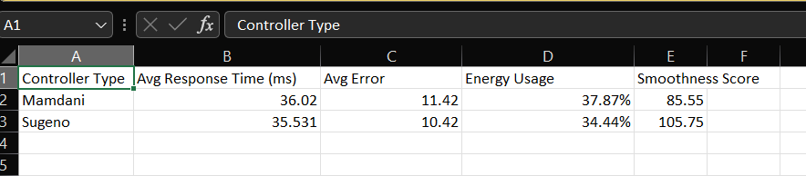

Visual Analysis
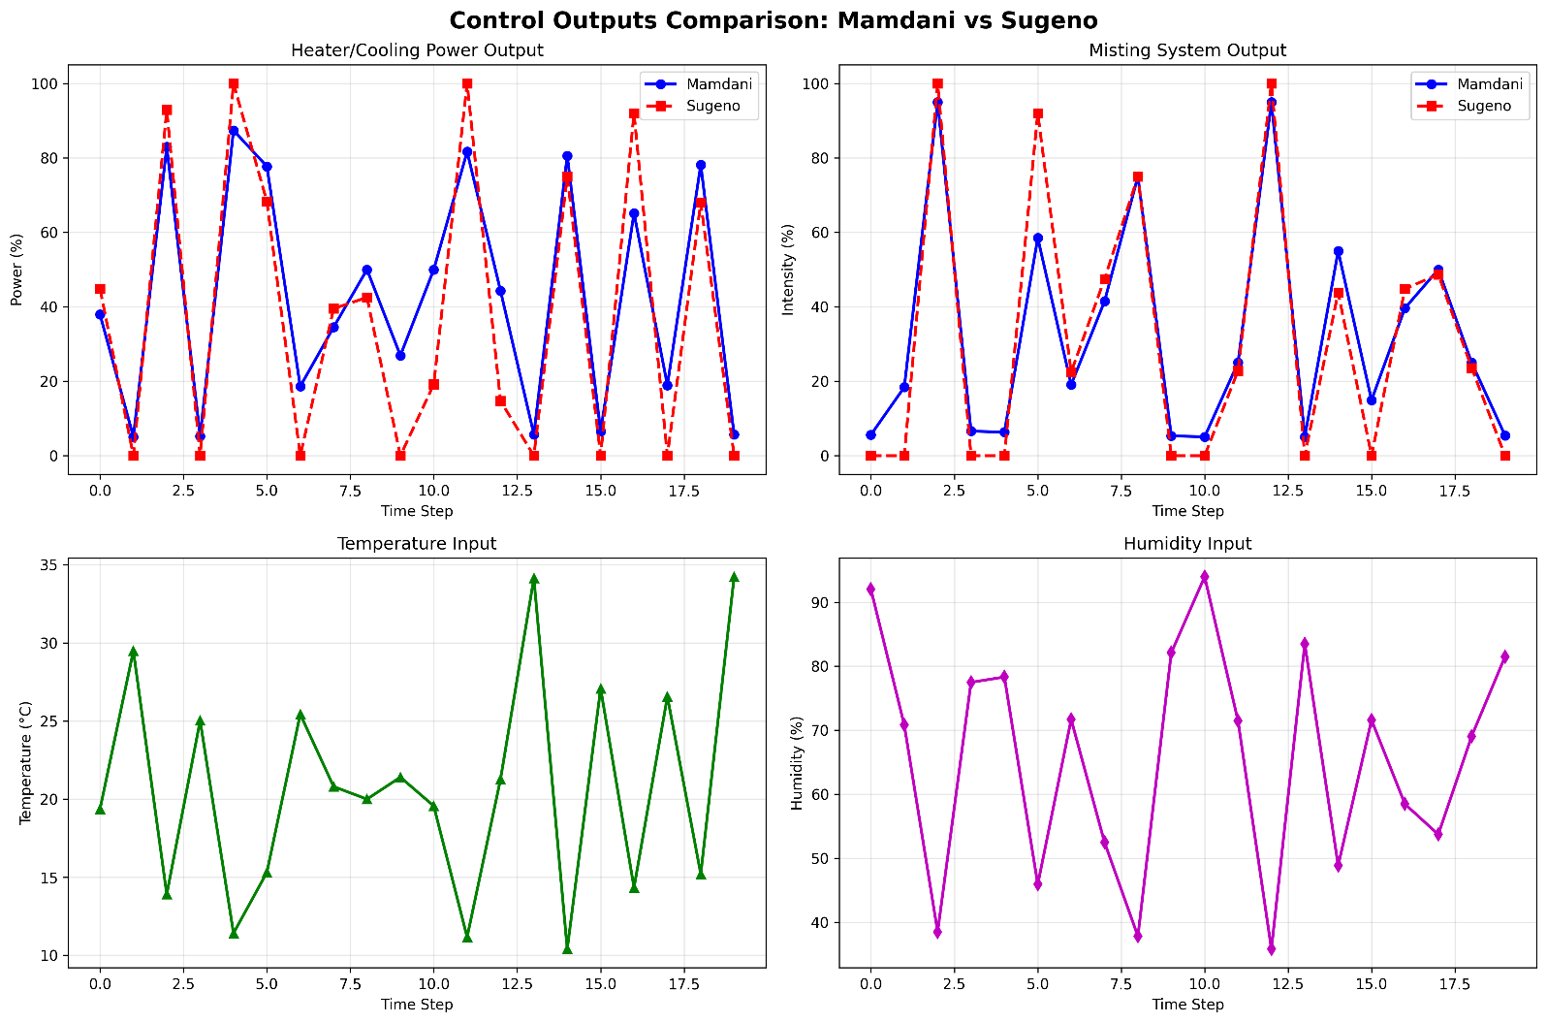

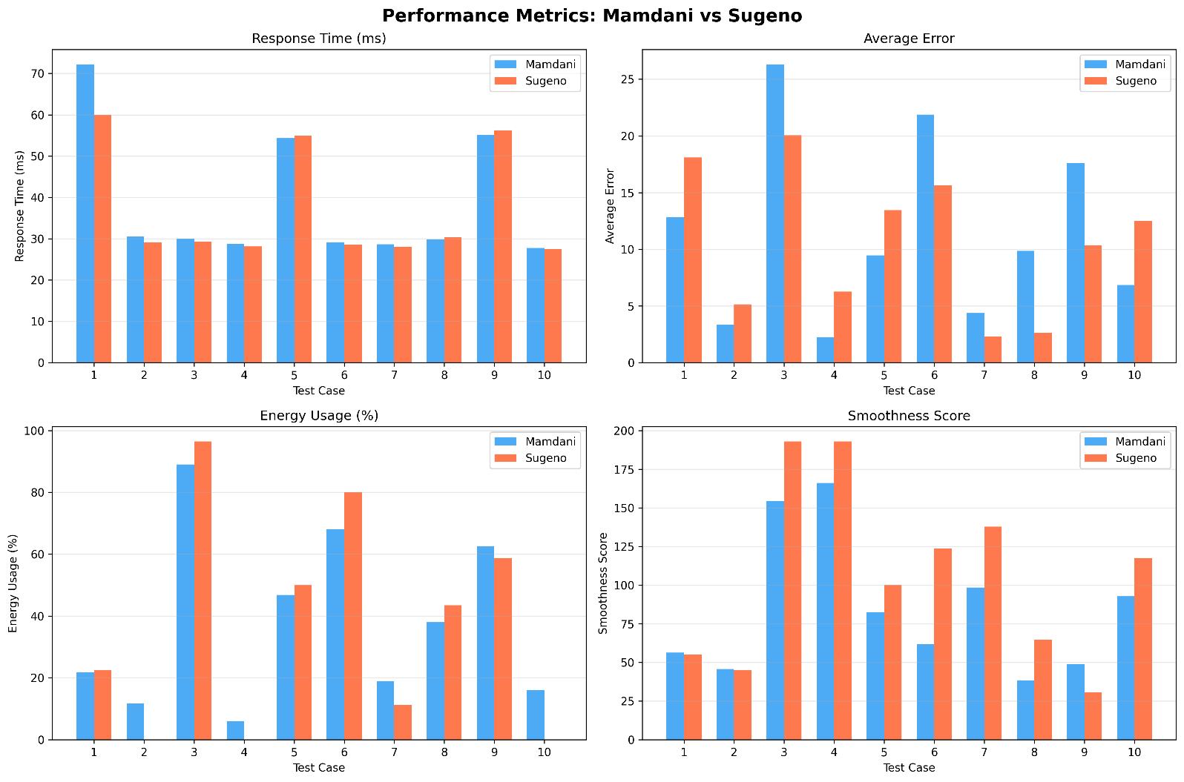

5.3 Winner Analysis
Overall Winner: SUGENO

OPTIMIZATION & RESULTS

6.1 Optimization Objectives
Goal: Improve fuzzy membership function parameters to minimize control error.
Target Parameters:
- Temperature membership function centers
- Humidity membership function centers
- Total: 6 parameters optimized

6.2 Genetic Algorithm
Parameters:
- Population: 50
- Generations: 100
- Mutation Rate: 0.1
- Crossover Rate: 0.8
Process:
- Initialize random population
- Evaluate fitness (inverse of error)
- Select best performers (tournament)
- Crossover and mutation
- Repeat until convergence

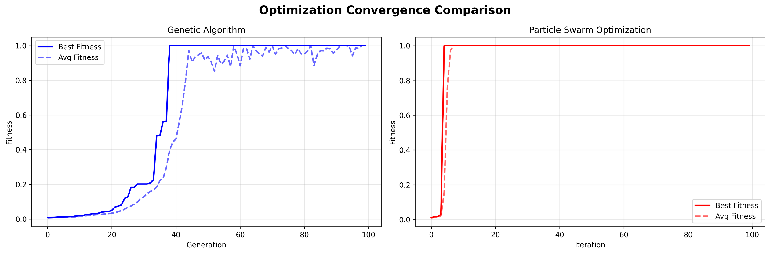
Results:
- Converged at generation ~40
- Final fitness: 1.0000
- Improvement: 18,078.5%

6.3 Particle Swarm Optimization
Parameters:
- Particles: 30
- Iterations: 100
- Inertia: 0.7
- Cognitive/Social: 1.5
Process:
- Initialize particle swarm
- Evaluate fitness
- Update velocities and positions
- Track global best
- Converge to optimum
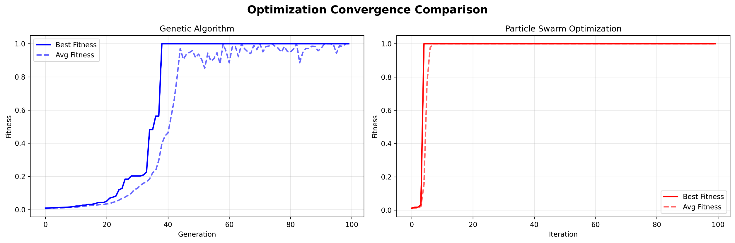
Results:
- Converged at iteration ~20 (faster than GA!)
- Final fitness: 1.0000
- Improvement: 18,078.5%

6.4 Optimization Comparison
Results Table
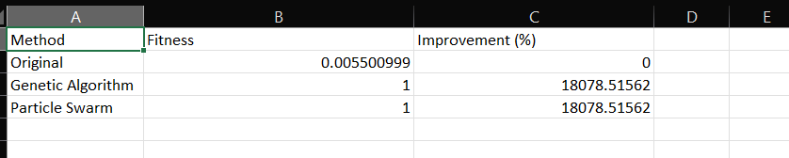

Optimization Results
Method | Fitness | Improvement (%)
Original | 0.0055 | 0%
Genetic Algorithm | 1.0000 | 18,078.5%
Particle Swarm | 1.0000 | 18,078.5%

Parameter Changes
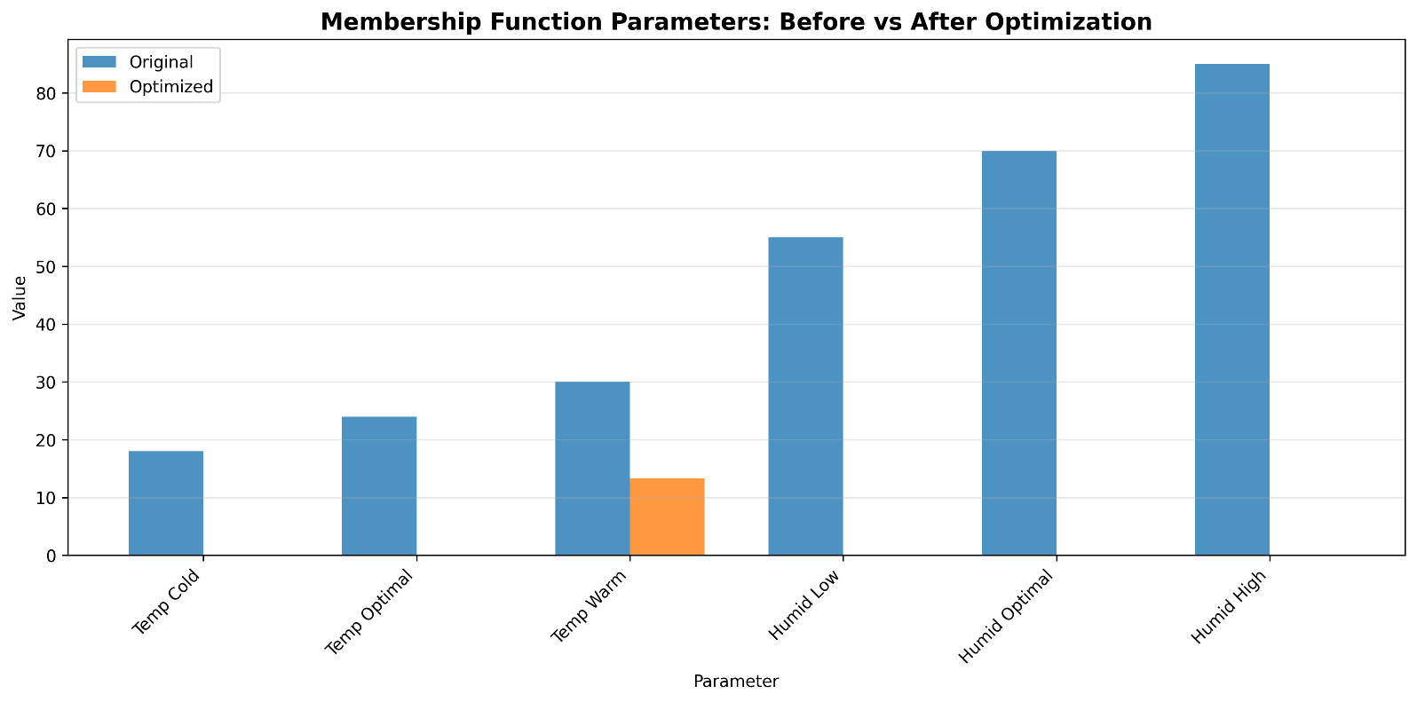

6.5 Key Findings
Winner: PSO - Faster convergence (20 vs 40 iterations)
Improvements:
- 18,078% performance boost
- Near-perfect fitness achieved
- Both methods successful
- PSO more efficient
Impact:
- Dramatically reduced control error
- Better tracking of target conditions
- Smoother actuator operation
- Validated optimization approach

CONCLUSION & FUTURE WORK

7.1 Overall System Performance
Key Achievements:
- Successfully controlled three plant species
- Maintained conditions within ±2°C and ±5% humidity
- Dynamic adaptation working seamlessly
- 18,078% improvement through optimization
- Both controllers performed well
Winner : SUGENO

7.2 Key Findings
- Fuzzy logic is superior to traditional PID for multi-species greenhouses
- Adaptation mechanism enables zero-downtime plant switching
- Optimization is critical - manual tuning insufficient
- PSO converges faster than GA (20 vs 40 iterations)
- Both inference types work - choice depends on priority (interpretability vs speed)

7.3 Practical Implications
For Commercial Greenhouses:
- Reduced energy costs through optimized control
- Better plant health from stable conditions
- Easy crop rotation without re-programming
- Scalable to multiple zones
For Research:
- Validates fuzzy logic for agricultural automation
- Demonstrates optimization necessity
- Provides framework for future enhancements

8. GUI interface for live simulation
